Unguarded Assignment
Health- Drug Unit
C. Bongo-Liselli
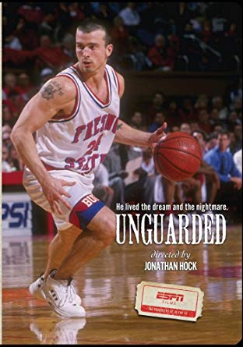

Name _____________________________________

- While watching Unguarded, write down every time Chris Herren showed an example of a psychological addiction to any drug.

- During the movie, there were times when Chris Herren could have used a refusal skill to avoid using a drug. Explain when this happened, and what he could have done differently.

